- S6002_1_GenStatisticsRelationCsvFile.py
Before plan
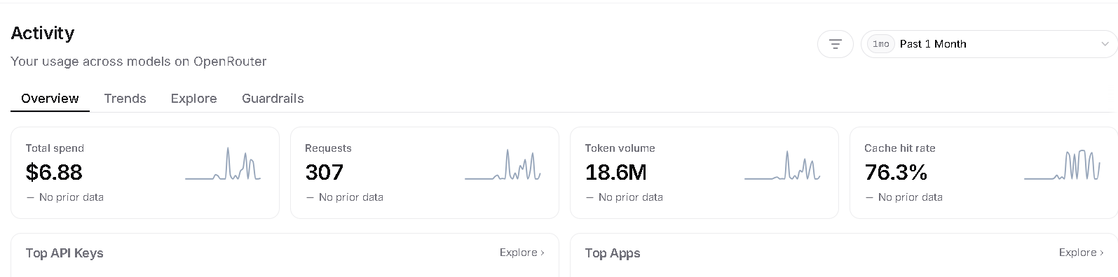
After plan before agent implement
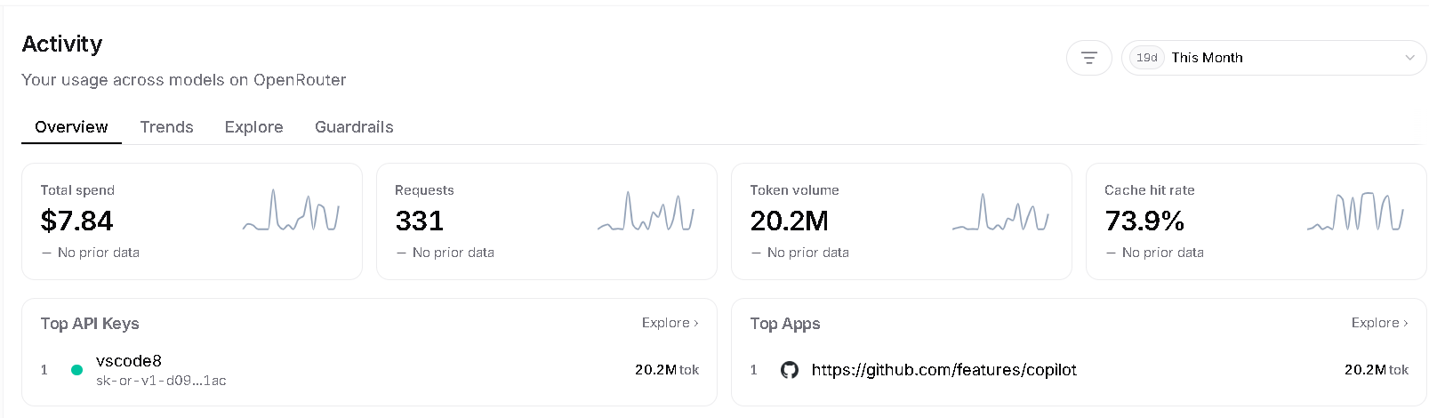

After agent implement
